RANCHO ROMERO ELEMENTARY FAMILY HANDBOOK 2023-24
This is a working document and will be updated as needed throughout the rest of the school year. Please see the date at the top for the most recent revision date.
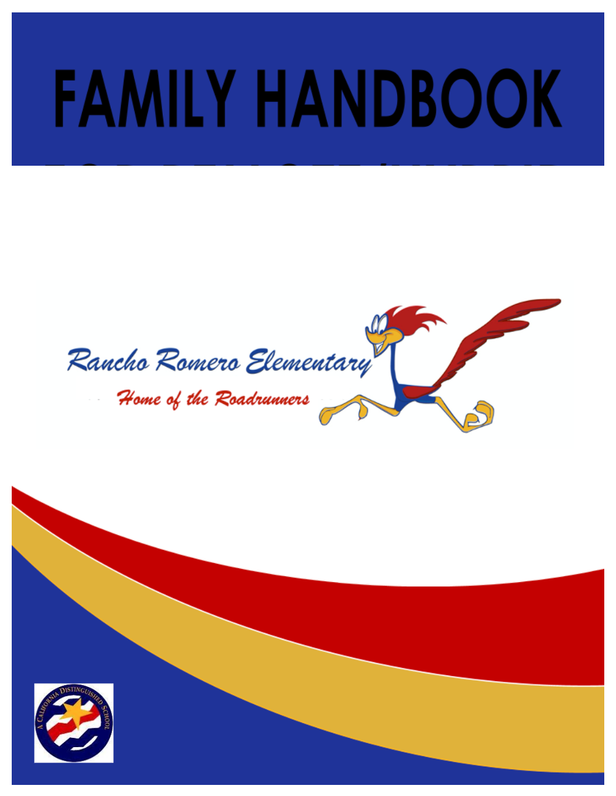

TABLE OF CONTENTS

SCHOOL CONTACT INFORMATION

RANCHO ROMERO ELEMENTARY SCHOOL MISSION

RANCHO ROMERO ELEMENTARY SCHOOL VISION

RANCHO ROMERO TEACHERS

RANCHO ROMERO SPECIALISTS

SCHOOL MAP

BELL SCHEDULE FOR TK/KINDERGARTEN

BELL SCHEDULE FOR GRADES 1-5

SAFETY

SCHOOL ARRIVAL AND DISMISSAL POLICY AND PROCEDURES

SANITIZATION/CLEANING INFORMATION

HEALTH INFORMATION

PARENTS RIGHTS AND RESPONSIBILITIES, POLICIES AND PROCEDURES

ATTENDANCE AND TARDY POLICIES, INDEPENDENT STUDY, AND EMERGENCY INFORMATION

MEDICATION AND LIFE-THREATENING MEDICAL ISSUES

VISITORS AND VOLUNTEERS ON CAMPUS

HOMEWORK POLICY AND RESPONSIBILITIES

GENERAL INFORMATION

CODE OF CONDUCT PHILOSOPHY, SCHOOL RULES, AND CONSEQUENCES AND DISCIPLINE

PLAYGROUND RULES, PLAY SKILLS, AND GAME RULES

CODE OF CONDUCT

PROGRAMS AND ORGANIZATIONS

SUPPORT PERSONNEL

SCHOOL CONTACT INFORMATION

Rancho Romero Elementary School
180 Hemme Avenue
Alamo, CA 94507
Office | 925-855-5700
24-Hour Attendance Line | 925-855-5799
Fax | 925-837-9030
Website | https://rres.srvusd.net/
San Ramon Valley Unified School District | 925-552-5500

Roopali Bali, Principal
rbali@srvusd.net

Diane Bournazos, Office Manager
dbournazos@srvusd.net

Elizabeth Tipton, Office Assistant
etipton@srvusd.net

RANCHO ROMERO ELEMENTARY SCHOOL MISSION

At Rancho Romero Elementary we are dedicated to providing:
- Rigorous standards-based curriculum and instruction
- Opportunities for all students to discover and cultivate their own individual interests and talents
- A physically and emotionally safe school environment that fosters trust, respect, and a sense of personal and civic responsibility
- A collaborative school community that draws on the strengths of all stakeholders to support our students and celebrate learning

RANCHO ROMERO ELEMENTARY SCHOOL VISION

Rancho Romero is a community of learners joined together in a nurturing and safe environment. All staff members are committed to providing students with the tools to become productive and responsible citizens. It is essential that our students acquire skills in gathering, organizing, and analyzing information as well as developing skills in critical thinking and problem-solving. Students will have access to current technology and use these tools in their everyday lives. They must be able to express themselves through written and oral communication as well as the arts. Students need to be actively engaged in both mental and physical activities to keep their minds and bodies healthy and fit. Parents and community members take an active role in supporting and encouraging all members of the school population. The teachers, support staff, and parents work together to prepare students for the future with high expectations for all and a unified commitment to education.
RANCHO ROMERO TEACHERS
First Name | Last Name | Grade/Specialist | Room
Kim | Kraft | TK AM | 23
Monica | Manuel | TK PM | 23
Megan | Mitchner | K | 22
Kim | Lohse | K | 24
Kathleen | Simmons | 1st | 4
Lauren | Barrett | 1st (Job share with Mrs. Simmons on Fridays) | 4
Melanie | Dotson | 1st | 2
Summer | Stamates | 1st | 1
Allie | Raney | 2nd | 3
Megan | Jacoby | 2nd | 5
Marissa | Holmes | 2nd | 6
Shelby | Alms | 3rd | 9
Jen | Harrington | 3rd | 8
Peggy | Cox | 3rd | 14
Deb | Varo | 4th | 19
Christian | Hicks | 4th | 21
Jen | Abbott | 4th-5th grade combo | 17
Jen | Clausen | 5th | 20
Jennine | Warbington | 5th | 16

RANCHO ROMERO SPECIALISTS
First Name | Last Name | Grade/Specialist | Room
Sara | Williams-Curran | TSA Admin | Tech
Angelyn | Brown | Liaison | Tech
Laura | Berchdorf | Resource Specialist | 18
JT | Wills | Psychologist | Psych
Mollie | Van Laar | Speech Pathologist | Speech
Jamie | Nguyen | Science/Math | 7
Marc | Trapani | PE
Rachel | McCutchen | Reading Specialist | Rdg. Room
Kim | Ritthaler | Reading Specialist | Rdg. Room
Alex | Deeman | Instructional Assistant, Reading | Rdg. Room
Christie | Browne | Math Specialist - Enrichment | 10
Julie | Ma | Instructional Assistant, Math | 10
Alicia | Smith | Music Teacher (Gr. TK-5) | 12
Christine | Bertolero | Instrumental Band (Gr. 4-5) | MUR
Leena | Heer | Counselor | Psych
TBD |  | SCIP | Rainbow Room
Julie | Sulzberg | Instructional Assistant, Art | 11
Sarah | Woerner | Library Media Coordinator | Library
TBD |  | Rainbow Para | Rainbow Room

SCHOOL MAP
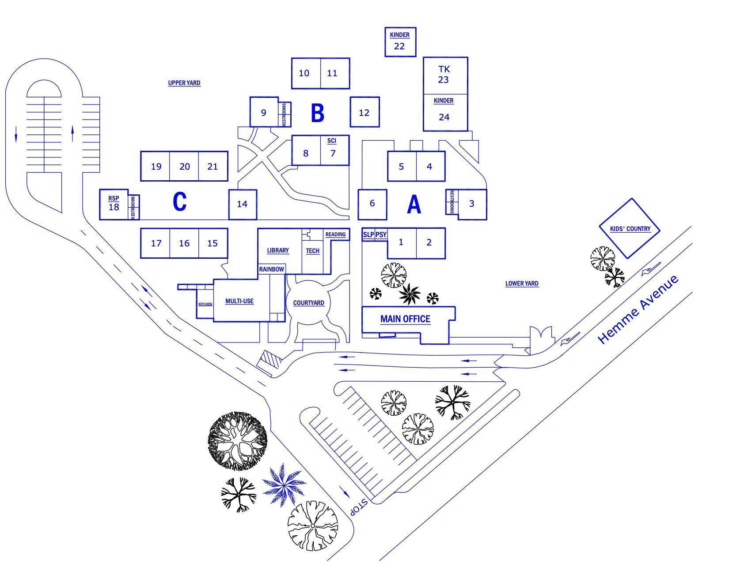

Rooms/Buildings

- A Pod - Rooms 1-6
- B Pod - Rooms 7-12
- C Pod - Rooms 14-21
- Kinder Pod - Rooms 22-24
- Library
- Technology
- Multi-Use Room (MUR)
- Administration
- Specialists
- Kids’ Country
BELL SCHEDULE FOR TK/KINDERGARTEN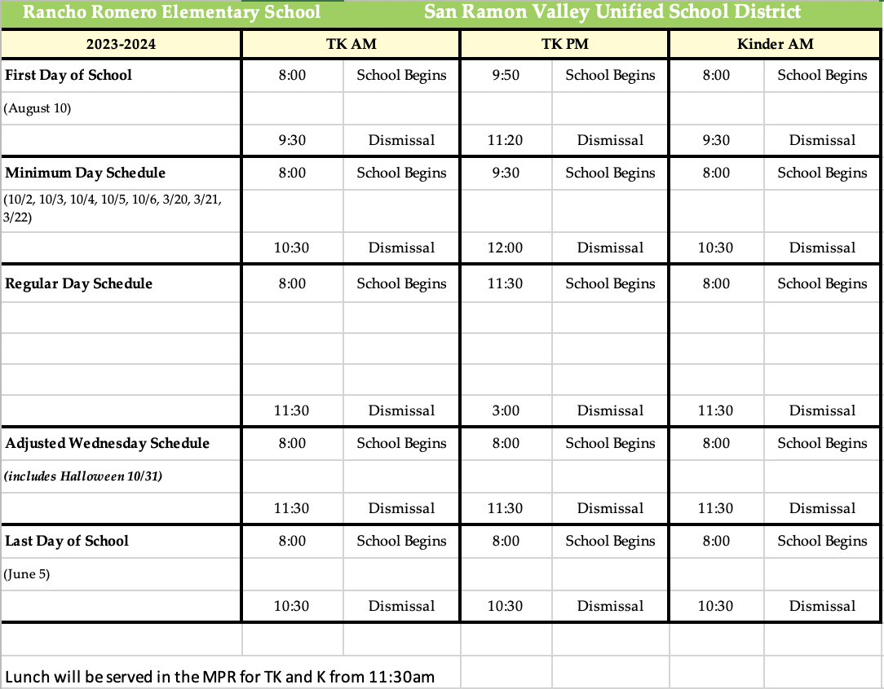

BELL SCHEDULE FOR GRADES 1-5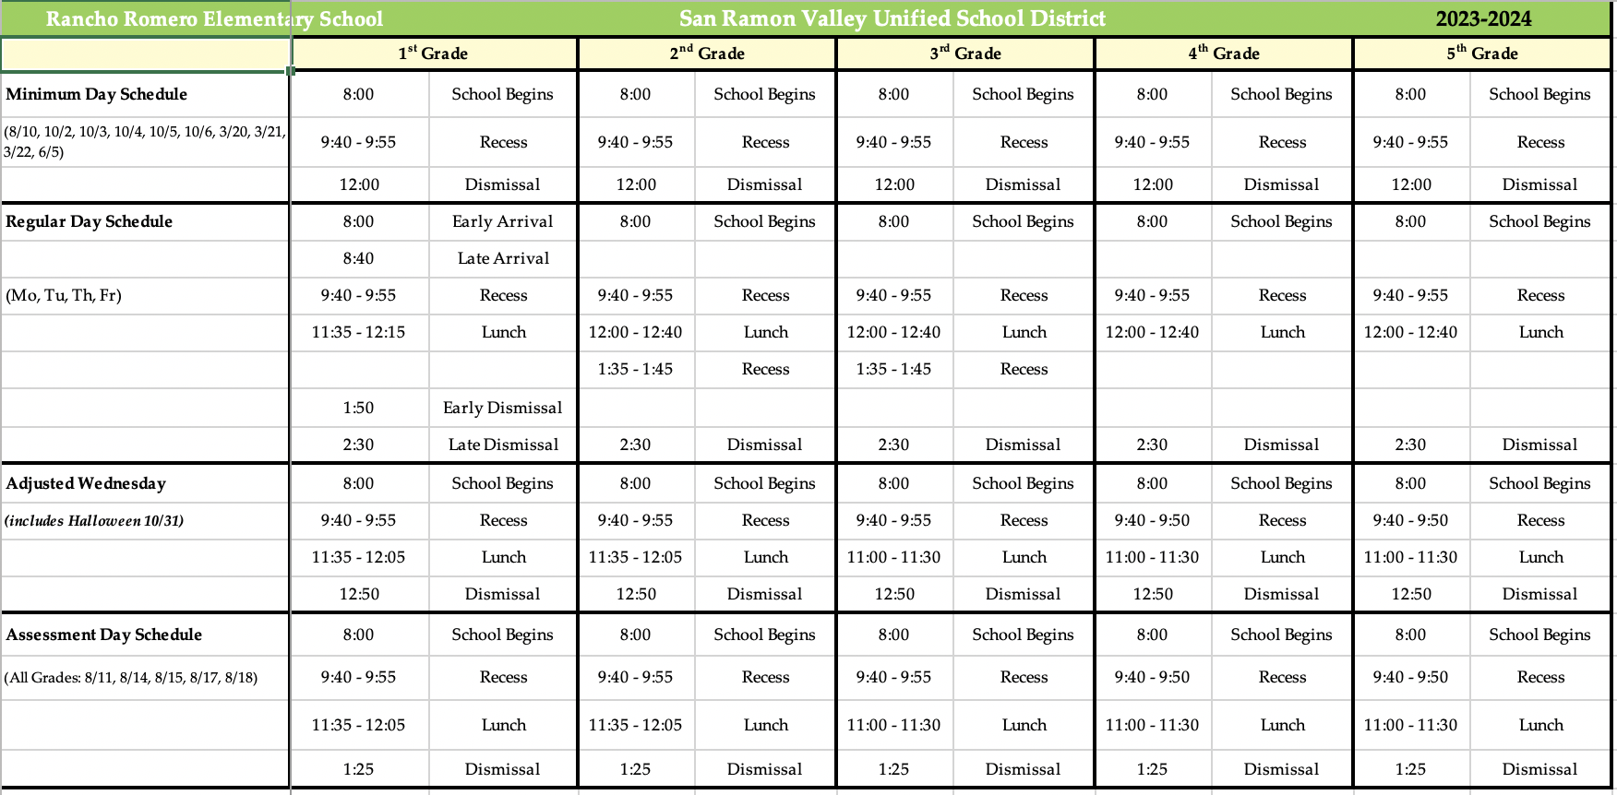
SAFETY

Hand Hygiene

Students are taught and encouraged to follow hand hygiene. This includes either washing with soap and water, or if soap and water is unavailable, use of a hand sanitizer. This may​ be performed at the following times, as feasible:

- Upon arrival to school
- Before and after using the playground equipment or other commonly used equipment
- Before and after using or touching frequently touched surfaces
- Before and after eating food
- Before and after using the restroom
- After coughing or sneezing
- Before dismissal

Student Illness

In Grades TK-K, if a child exhibits symptoms of COVID-19 or another illness, the teacher will call the office and someone from the office will come to escort the student to the office. In Grades 1-5, teachers will call to prepare the office staff to receive the sick child and the student will walk themselves to the office. The child who is ill will go to the nurse's office. If it is determined that the child needs to be picked up, the child’s parents must make arrangements to have the student picked up within 30 minutes. During that wait time, the child will wait in the nurse’s office.

SCHOOL ARRIVAL AND DISMISSAL POLICY AND PROCEDURES

Arrival Policies and Procedures
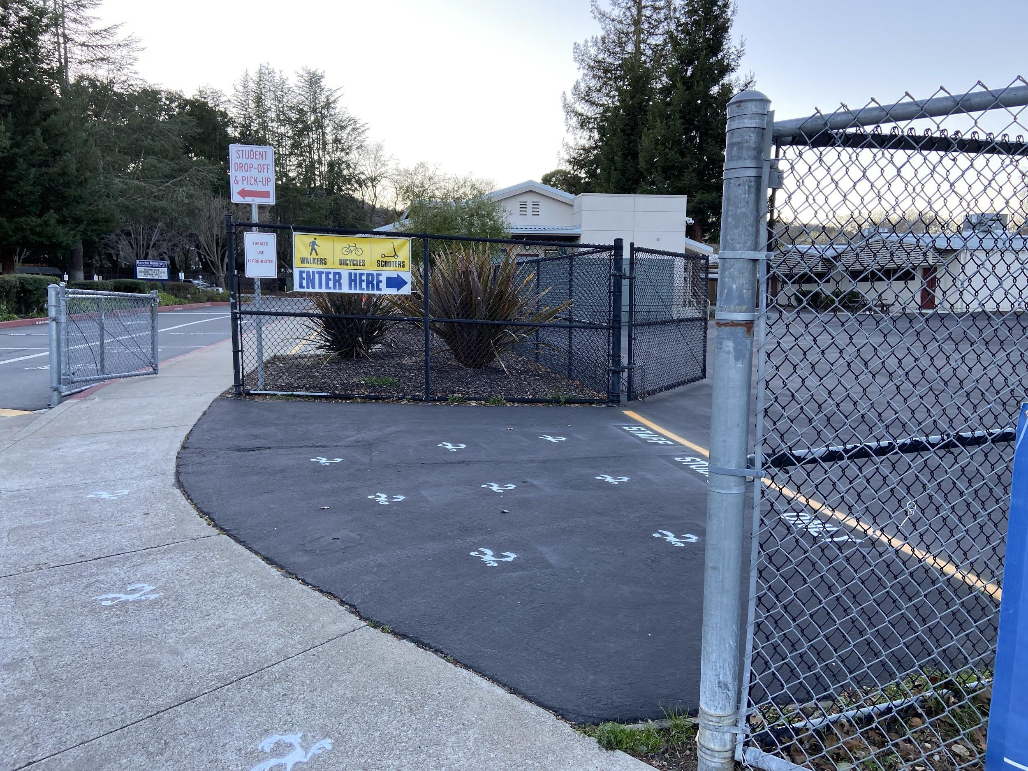 | 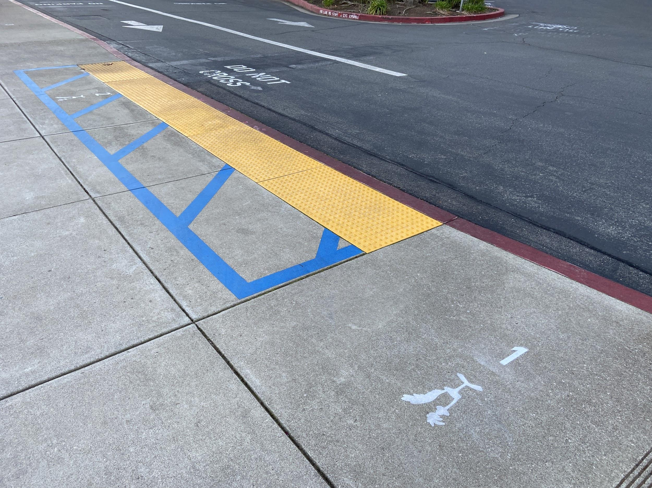 | 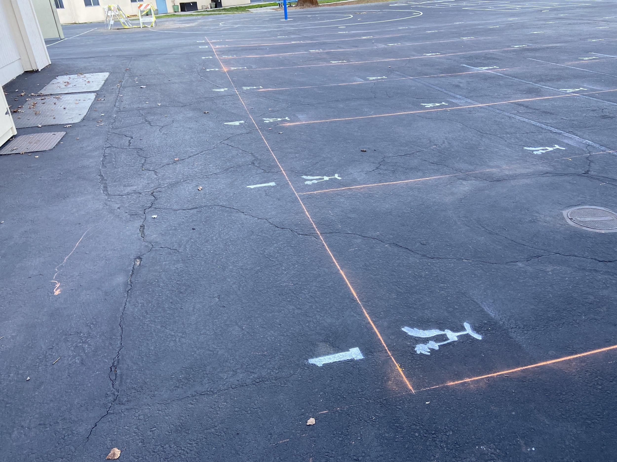 | 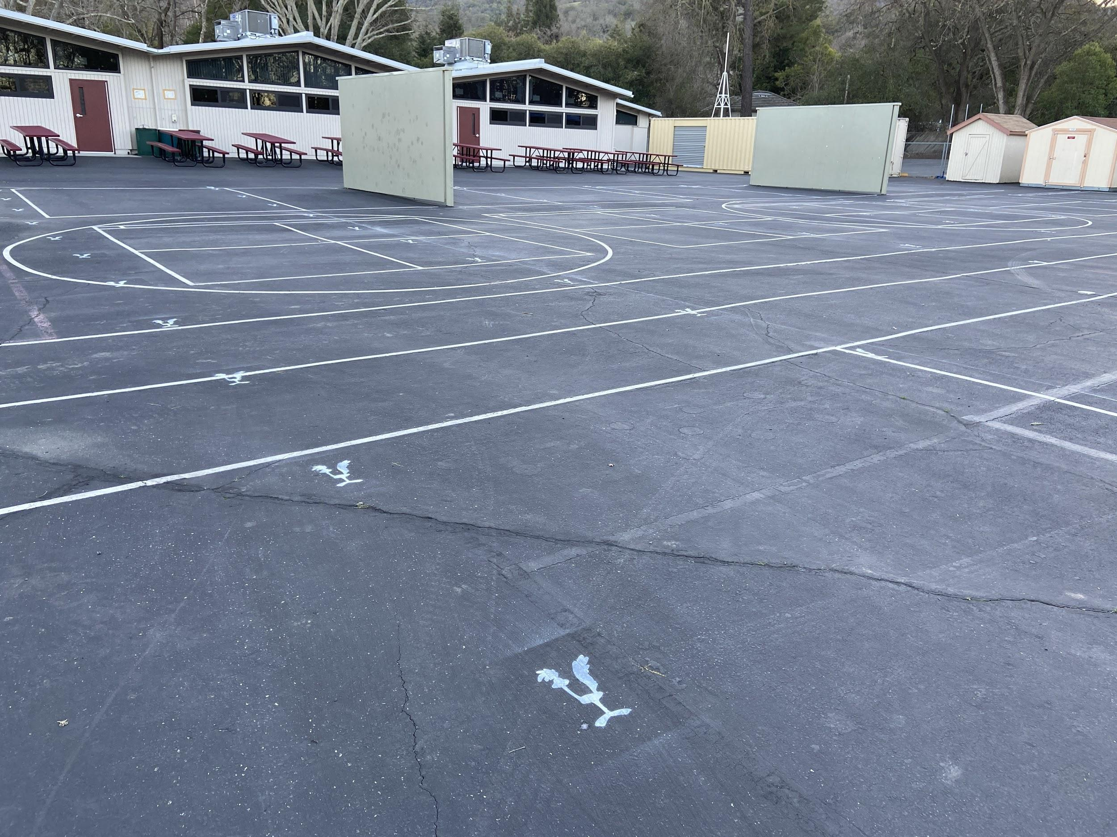
Walkers, bikers, and scooters enter and exit school on Hemme Avenue. | Car riders drop off and pick up area in front of the school. | Grades 1-2 line up on the designated line for school on Lower Yard. | Grades 3-5 line up on designated line for school on the Upper Yard.

- In an effort to help with the morning traffic and to reduce tardiness, we will be starting drop-off earlier this year. We will reevaluate the effectiveness of early drop-off before finalizing the plan for the following school year. This year, parents will have the option of dropping off students between 7:30am-8:00am for students with class starting at 8:00am.

- Students should arrive at school no earlier than 7:30am unless accompanied by an adult or for a specific event. There will be no supervision prior to 7:30am. If you arrive early then please stay with your child till 7:30am. From 7:30am-7:45am, only the MUR will be open for students and students will be supervised there. Walkers and bikers arriving at 7:45am onwards will walk through the gate on Hemme Avenue. Car riders, TK (AM) and Kinder students will get dropped off in front of the school. Students in grades 1-5 will be picked up from the MUR by the morning supervision teachers and enjoy a morning recess between 7:45-7:57am. Grades 1-2 will have morning recess on the lower yard and Grades 3-5 will have morning recess on the upper yard. At the first bell at 7:57am, students will line up on their class line and will be taken to the classroom by their teacher to start the school day at 8:00am.
- TK (PM) students will be dropped off at the 4th-5th grade pick-up area between 11:15-11:25am where the TK teacher will be present to receive them. After 11:25am, please park and walk your student into the office.
- TK/Kindergarten teachers will be sharing more information about arrival and dismissal directly with parents at the Back to School Night on the evening of the first day of school.
- When it is raining, students arriving between 7:30-7:45 am will be supervised in the MUR. At 7:45am students in grades 1-5 should proceed directly to their classroom rather than to the upper or lower yard area. They will line up in the hallway outside their classroom door. TK/Kindergarten students arriving between 7:45-8:00am and the TK (PM) students will be dropped off in the front of the school, at the office gate.

Map for Entering the School

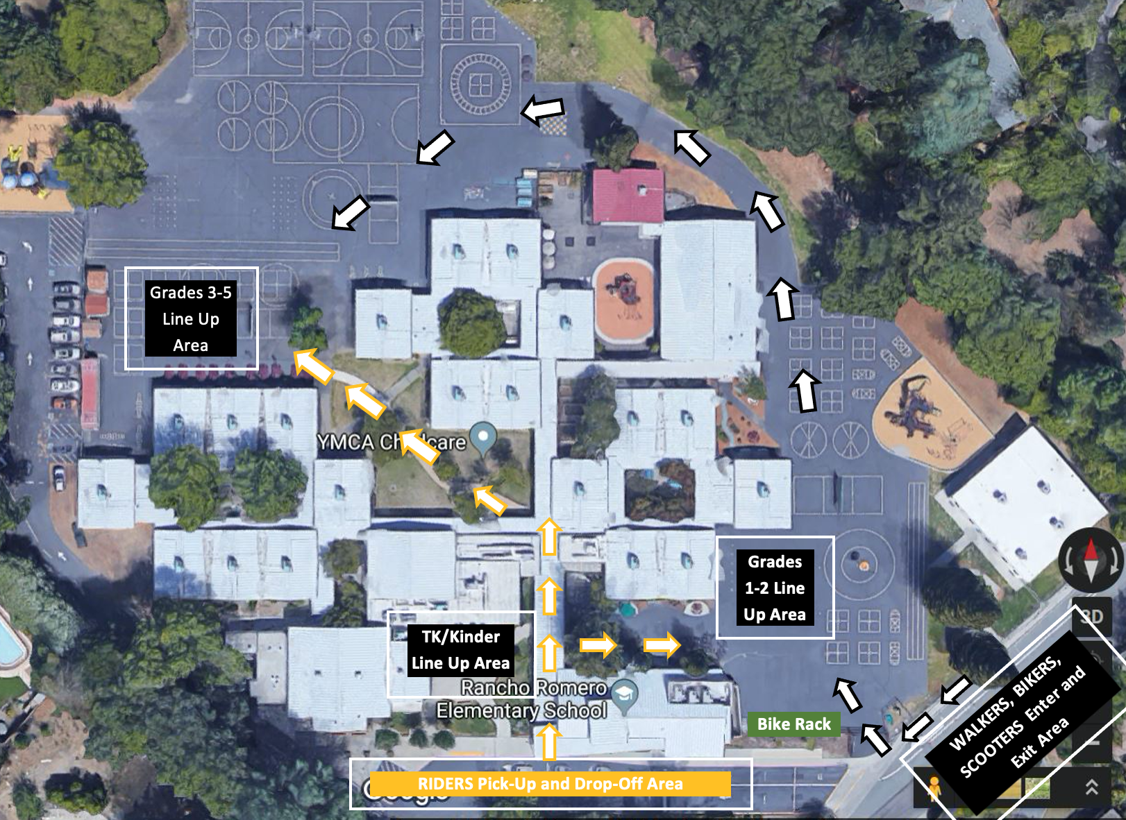

Dismissal Policies and Procedures

- Walkers and bikers should exit through the lower playground through the gate on Hemme Avenue. Car riders, TK and Kinder students will get picked up in the front of the school. Parents should display the student name tag/placard in the window.
- Parents of TK, Kindergarten, and early dismissal 1st graders will receive specific dismissal instructions from teachers.
- Parents should make arrangements/plan for how you will reunite with your child BEFORE the school day begins. Phone calls to change plans during the day to the classroom will only be made in emergency situations as they are disruptive to the learning environment.
- Students that have specific one-time instructions for dismissal need to give a signed note to their teacher explaining the instructions at the beginning of the day or have this arranged in advance with the teacher.
- All students need to be picked up no later than 15 minutes after the dismissal bell, as there is no supervision on campus after this time.
- If students are picked up in front of the school, students should remain in designated pick up areas until the parent arrives. Students in Grades 4-5 (without younger siblings) will be picked up in the designated Grades 4-5 area. All other students will be picked up in front of the school, near the office.
- Students who are picked up by other families (e.g. carpools or walking groups), need to have that family’s contact information included in their emergency contacts on the Parent Portal. Failure to provide proper information may result in students remaining at school to verify proper dismissal instructions with parents.

Map for Exiting the School

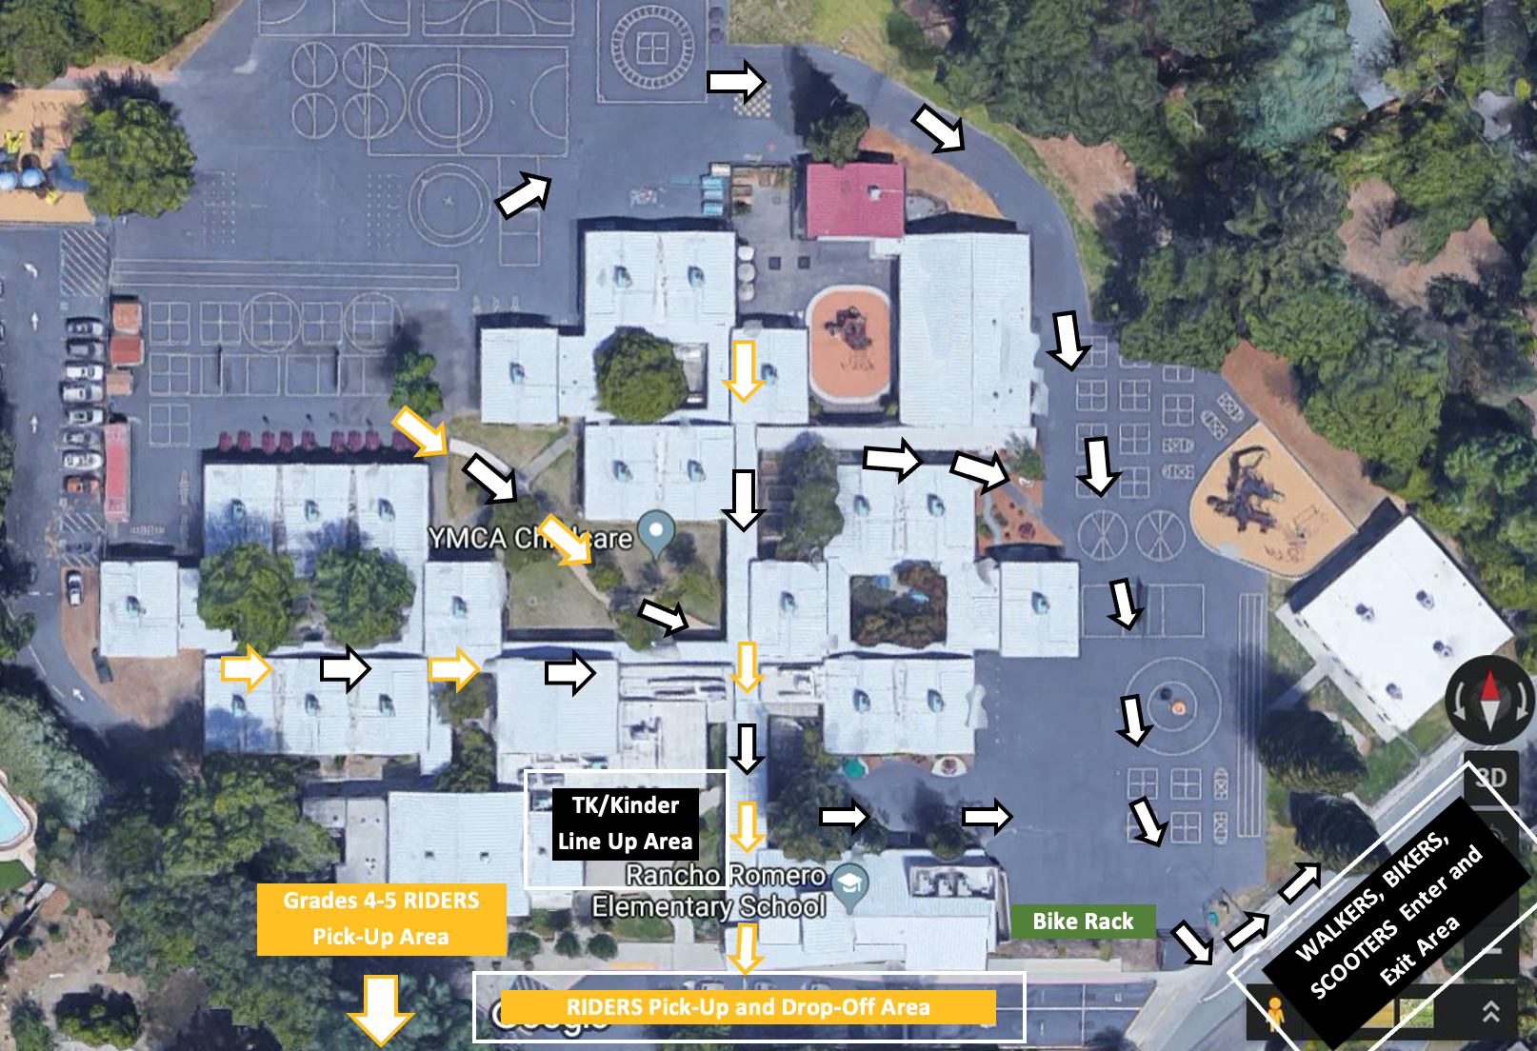

Safety Practices for Walking or Riding to and from School

- Follow directions of the school crossing guard at all times.
- Walk, bike, scooter or skateboard to and from the Iron Horse Trail.
- Wear a helmet when riding anything with wheels.
- Use the student sidewalk on the north side of Hemme Avenue.
- Stop and look before crossing Barbie Lane.
- Press the button to cross Hemme Avenue.
- Wait, look, and listen before crossing Hemme Avenue.
- Park and lock the bike, scooter or skateboard neatly in a bike rack.

Recess

Students will wash or hand sanitize their hands before heading out to recess. Teachers will escort their students to the playground. Teachers will make sure students are aware of boundaries of the play area for the day. Students must STAY SEATED the entire time while they are eating. Upon reentry to the classroom after recess, all students are encouraged to wash or sanitize their hands.

Lunch

Students will wash or sanitize their hands before heading out to lunch. Teachers will escort their students to the lunch area. If students have a cold lunch, they will go straight to the lunch area. If they need a school lunch, students will go through the Multi-Use Room (MUR) to grab lunch and head to the lunch area. Depending on grade level, students will eat first and then head to recess or vice-versa.

Rainy Day Procedures

On rainy days, students will eat lunch in the MUR or another covered area and follow the rainy day lunch schedule.

Bathrooms

Teachers will work with their students on bathroom procedures. Students will walk into the bathroom, check for an open stall. If both stalls are occupied, then the student should exit the bathroom and wait outside until a stall becomes available. Upon leaving the restroom, students must wash their hands.

Drinking Fountains/ Bottle Filling Stations

All drinking fountains on campus will be on for students to use. Students are encouraged to bring their own water bottles and can refill it at any of the three bottle filling stations on campus. Students should clearly label their water bottles with first and last name and room number.

Student Learning Materials and Sanitization

Students will be able to keep most of their belongings on campus. Whenever possible, students will be given their own materials to use. When needed, material can be shared. Teachers will have students wash or sanitize their hands before using shared equipment. All students in grades 2-5 will have their own chromebook to use at school. Students in TK-1 will have their own ipad to use.

Field Trips
Students will be going on in person field trips. Use of buses is encouraged over private vehicles. More information will be coming from your child’s teachers on this topic.

Student Who Leave Classrooms Without Permission

Teachers will immediately call the office to report that the child has left the classroom. Office staff will take care of locating the child and bringing the child back to the classroom. The child’s parents will be notified of the incident. Student will be provided with appropriate intervention support. If the child continues to not follow the procedures for the classroom, the child may be moved to the remote model of learning.

Student With Pre-Existing Health Conditions

Students with health conditions that may need additional accommodations due to possible COVID-19 exposure will have their health plans reviewed by the school nurse and any additional accommodations implemented as needed. This is on a case-by-case basis and will be addressed in a meeting with the parent, nurse, and principal. Appropriate PPE will be worn when working in close contact to a student with any health related issue or intervention. Parents will be contacted (as will all students’ parents) if there is any reason to believe they have had COVID-19 exposure.

SANITIZATION/CLEANING INFORMATION

Playground Cleaning and Sanitizing Information

There will not be specific structure sanitizing after each student's use. Natural sunlight and associated surface temperature "rapidly inactivates" the coronavirus and other viruses within minutes. On a rolling-overnight-basis across approximately 12 hours, temperature and humidity also "rapidly inactivate” and otherwise damage the virus.

Classroom Cleaning

The custodian will clean TK and Kinder classrooms every day. All other classrooms are cleaned every other day. This includes (but not limited to) the door handle, sink, countertops, light switches, each student’s desk, and vacuuming carpets and rugs. Trash will be removed from all classrooms every day.

Student Bathroom Sanitization

The custodian will sanitize each of the student bathrooms every day. .

HVAC and Ventilation Information

The District has upgraded all HVAC air filters to MERV-13, which meets the guidance from the American Society of Heating Refrigerating and AirConditioning Engineers (ASHRAE) on how best to handle COVID-19. Outdoor Air Ventilation: The ventilation systems all meet California Title 24 code-required ventilation rates. Wherever possible, the District has opened the minimum outdoor air dampers (as high as 10%) to reduce or eliminate recirculation.

Fresh Air

We encourage fresh air as much as possible by opening windows or doors where practicable. If opening windows/doors poses a safety or health risk (i.e. smoke, pollen, etc.) to persons using the facility, then the windows/doors will remain closed.

HEALTH INFORMATION

We strive to create a healthy learning environment for our students, and therefore, it is important not to send your child to school if they are sick.

Your child may be excluded from school in accordance with California Education Code section §48210-48214 and section §49451. “Whenever there is a reason to believe that the child is suffering a recognized contagious or infectious disease, he/she shall be sent home and shall not be permitted to return until the school authorities are satisfied that any contagious disease does not exist.” To see district policy, click here.

Health Screening at Home

All STUDENTS and STAFF are requested to take this health self-assessment every day before coming to school. Younger children should be assisted by a parent or guardian. You do not need to submit any proof of assessment to your school site. Your honesty is expected as we all do our part to keep our school environments safe for staff and students.

DO NOT COME ONTO CAMPUS IF YOU ANSWERED YES TO ANY OF THE BULLET POINTS BELOW and CONTACT YOUR HEALTH CARE PROVIDER:

HAVE YOU:

- Had a temperature at or above 100.4° or reason to be concerned you may be developing a fever? If you don’t have a thermometer, additional fever signs and symptoms may include: sweating, chills and shivering, headache, muscle aches, loss of appetite, irritability, dehydration, or general weakness.

- Experienced a new cough that you cannot attribute to another health condition?

- Experienced a new shortness of breath that you cannot attribute to another health condition?

- Experienced a new sore throat that you cannot attribute to another health condition?

- Experienced new muscle aches that you cannot attribute to another health condition or a specific activity such as physical exercise?

- Experienced any chills that you cannot attribute to another health condition?

- Experienced a new loss of taste or smell.

- Experienced new onset of nausea, vomiting or diarrhea?

- Currently have or are suspected of having COVID-19?

This list is not an exhaustive list of all symptoms. Other less common symptoms have been reported, including gastrointestinal symptoms such as nausea, vomiting, or diarrhea. Visit the Center for Disease Control (CDC) or the California Department of Public Health (CDPH) website for additional information.

The presence of OTHER non-COVID-19 related SYMPTOMS that warrants keeping your child home.
- Eyes that are red, swollen, crusting, and/or draining
- Skin rashes of unknown origin or contagious rash and may require a return to school clearance from a health care provider

Student Pick-Up Due to Illness
Students who need to go home due to illness ​must be picked up within 30 minutes​. Please review your emergency contacts and make arrangements with an authorized individual if you are unable to pick up your student within the 30 minute window.
Positive COVID-19
If a student tests positive for COVID-19, the family must notify the school within 24 hours. Notification shall be provided to the school office. The student may return to school based on the guidance provided by the school. To see more Covid health and safety information, click here.

PARENTS RIGHTS AND RESPONSIBILITIES, POLICIES AND PROCEDURES

Parents Rights and Responsibilities

Parents have the right to expect that attention will be given to the academic, social, physical, and emotional needs of the students in an atmosphere which treats students with dignity, fairness, and consistency. Parents share the responsibility to support the school in its efforts to provide an exemplary program for students. Parents also have the responsibility to:

- Send students to school on time each day.
- See that the students receive a proper diet and ample rest.
- Communicate dismissal plans to students prior to dropping them off at school (see: Calling Teachers and School Office).
- Make sure students come to school with all materials, books, assignments, and masks.
- Provide a quiet time and place for study.
- Show an interest in the student’s day.
- Communicate with the teacher regarding progress reports and any concerns or questions.
- Keep all conference appointments or notify the school to the contrary.
- Work cooperatively with the school as a student’s education is a shared responsibility.
- Refrain from taking students out of school for vacations throughout the year.
- Keep emergency information updated in the Parent Portal.

Calling Teachers and School Office

The office staff has been instructed not to interrupt classrooms during instructional time. Parents are requested to communicate with teachers via written correspondence and email. Classrooms will be interrupted ONLY in the case of an emergency. In order to minimize interruptions we ask that parents make arrangements with their students regarding pick-ups, etc., prior to the school day. Students may not use the telephone to call parents when they forget to bring items or to inquire about/change their after-school pickup plans. We ask that parents check information in the Roadrunner News, the school website, and Family Handbook prior to calling the office.

Leaving School During Class Time

Students, who leave school for any reason other than at dismissal time, must be signed out in the office by the parent/guardian or a person preapproved by the parent/guardian prior to leaving campus. Contact the office and teacher about early dismissal. Students will not be released to people other than parents/guardians without a parent’s/guardian’s prior written or verbal permission (email or phone call to the office).

Forgotten Items

The delivery of any and all items is NOT allowed. This includes, but not limited to: snacks/food from home, homework, instruments, books, technology, personal protective equipment, any and all other items and materials.

Moving or Leaving School

When a student moves or leaves the school, parents are responsible for contacting the office (by email) and teacher to verify that all books, musical instruments, library books, etc. have been returned.

ATTENDANCE AND TARDY POLICIES, INDEPENDENT STUDY, AND EMERGENCY INFORMATION

Attendance Policy

It is important that students are attending school regularly. It is the responsibility of the parent/guardian to correct all absences with the office within two (2) school days. Failure to do so will result in a CUT for each absence. California’s compulsory education laws require children to attend school, with a limited number of specified exceptions. Under state law, a pupil who is tardy or absent for more than 30 minutes during the school day on three (3) occasions in one school year, is considered truant.

The compulsory school attendance laws of the State of California require both punctual and regular attendance on the part of the child. Excessive absences and tardies can affect students’ academic and social progress.

Chronic absenteeism will be reported yearly to the state. Chronic absenteeism is defined as missing ten percent or more of the academic year for any reason, including excused and unexcused absences. In an academic school year of 180 days, 10% is equal to 18 days.

If you have questions regarding attendance, please contact our office at (925) 855-5700. You can also email our office at rroffice-staff@srvusd.net.
It is the responsibility of the parent to notify the office of any attendance issues by calling the 24-hour attendance line
at 925-855-5799 before 8:00am on the day of the absence

Tardy Policy

Students are expected to be at school on time each day. Punctuality is a life-long skill, which is stressed at Rancho Romero. If a student is late, for any reason, he/she must go to the front office to get a late pass. Parents will be contacted when a student is repeatedly late to school and appropriate consequences will be enforced.

Independent Study Contract

If you know in advance that your student will be absent for five or more days for non-medical reasons, you may request an Independent Study Contract (ISC).

- Can be requested for 5-14 consecutive days.
- Requests must be submitted 3 days in advance for contracts up to 10 days. Contracts for 11 to 14 days require a 5 to 10 day notice. No contracts are allowed for the beginning/end of the school year.
- Does not replace teaching.
- ISC assignments are due on the date of return.
- If ISC assignments are incomplete, requests may be denied in the future.
- ISC must be requested by following this link.

Online Emergency Information
Students, who become ill at school and/or have medical appointments
and must leave during school hours,
MAY BE RELEASED ONLY TO INDIVIDUALS LISTED ON THE CAMPUS PORTAL.
IT IS IMPORTANT TO KEEP EMERGENCY INFORMATION UPDATED
by logging online to the Campus Portal.

MEDICATION AND LIFE-THREATENING MEDICAL ISSUES

Medication During School Hours

If your child needs medication while at school, please have your health care provider complete the appropriate medication form located on the district website. You can access the forms at the following links: Form A is used for students with life threatening allergies (epipens). Form B is used for any other medication at school. Medications cannot be dispensed to students unless the appropriate form is signed by his/her physician and is on file in the office. This applies for both prescribed and over-the-counter medication. This form is available on the San Ramon Valley Unified School District (SRVUSD) website or click here. Students should not be given medications of any kind to bring to school.
- Medication must be brought to school by the parent or adult representative.
- Medication must be brought to school in the original container.
- Over-the-counter drugs must also have a completed form on file.
- All medications must be kept in the office.
- This form must be renewed whenever the prescription and/or dosage changes and at the beginning of each school year.
A parent or adult representative must pick up unused medication at the end of the school year or when the medication order expires. Medication that is not picked up will be discarded.

Life-Threatening Medical Issues
If your child has a medical problem that might result in a life-threatening emergency situation at school (i.e. cardiac disorders, diabetes, severe asthma, severe allergic reactions to insects or food, or other miscellaneous life-threatening conditions), a Medical and Emergency Health Care Plan form needs to be completed by the parent, signed by a doctor, and returned to school.

VISITORS AND VOLUNTEERS

Visitors

Our office is open on weekdays from 7:30am-4:00pm. We are also happy to assist you by phone (925-855-5700) or email (rroffice-staff@srvusd.net).

Volunteers

Rancho Romero parent volunteers are an integral part of our school community. Parents help in various ways in the classrooms and the library. Parents also help on field trips and with special activities. Each classroom has a Room Parent who coordinates volunteers for classroom activities and programs.

To volunteer on the Rancho Romero campus, you MUST first be cleared through the SRVUSD volunteer process. Click here to start the process. Please make sure to have prior confirmation from the classroom teacher before showing up for volunteering in the classroom. All volunteers must sign in at the office and get a volunteer badge to wear before going to a volunteer assignment on the school site. This enables us to reach you in case of an emergency and to monitor volunteers on our campus. All parents who volunteer must adhere to the masking policy in place at the time of volunteering.

A few rules for all volunteers, drivers and/or chaperones:

- Check in at the office and wear a school-issued badge before going onto campus.
- Practice professionalism: arrive on time, turn off cell phones, dress appropriately, etc.
- Meet with the school administrator or designee in charge of the school trip to review policies and procedures that are specific to the trip being taken.
- Do not bring infants or non-school-age students to school with you when you are volunteering in the classroom. Volunteers are asked to make arrangements for off-campus childcare.
- Use staff restrooms only.
- Maintain confidentiality of information obtained through your volunteer efforts.
- Respect the privacy of everyone in the classroom. This includes materials you may see on the students’ or teachers’ desks (i.e. test scores, graded papers, notes, etc.).
- When addressing student behavior: ask politely twice, then inform the teacher.
- Do not consume or have in their immediate possession the following items at any point during a school-sponsored trip:
  - Alcoholic beverages
  - Tobacco-based products
  - E-cigarettes
  - Intoxicants of any sort

The school reserves the right to revoke volunteer privileges at any time.

HOMEWORK POLICY AND RESPONSIBILITIES
Homework should prepare students for and reinforce classroom learning. Homework is an integral component of education that deepens student learning and understanding. When assigned, homework will contribute to the healthy development of the whole student. Homework will be meaningful, purposeful, and appropriate.

Homework For All Grade Levels

- Homework is defined as any work assigned to be completed outside of class.
- The amount of homework assigned to students is different in elementary, middle, and high school. The amount of time a student spends on assigned homework depends on factors such as the student’s needs, learning ability, subject, school schedule, testing schedule and assigned homework due dates. Time spent on homework shall be balanced with the importance of personal and family well-being, and the wide array of family obligations experienced in our society today.
- Parents and teachers shall make students aware that learning occurs at home, school, and in the world around them.
- Homework shall be the result of collaborative efforts, thoughtfully considered, and coordinated to improve student learning.
- Homework shall be purposeful and meaningful to students. Legitimate purposes for homework include practicing a skill or process that students can do independently but not fluently, elaborating on information that has been addressed in class to deepen students’ knowledge, and providing opportunities for students to explore topics of their own interest.
- Reading is an integral part of learning and is a consistent part of homework.
- Homework will reflect the accommodations and modifications of curriculum that are stated in students’ IEP or 504 plans.
- There shall be no homework assigned during school recesses. (Thanksgiving Break, Winter Break and Spring Break). Projects assigned before recesses must not require any work to be completed over the break.

Grade-Level Homework Guidelines for Elementary School

- Reading is an integral part of learning. In the primary grades (K-3) homework will consist primarily of reading and a limited number of independent exercises to reinforce previously taught basic skills.
- Except for reading, homework at the elementary level shall not be assigned over weekends, or holidays.
- At the upper grades (4-5), homework consists of completing, practicing, preparing, or extending core academic skills and is designed to build independent study habits.
- Below are the time limits for elementary homework:
  - K-1 no more than 30 minutes of homework per night (reading included).
  - 2-3 no more than 45 minutes of homework per night (reading included).
  - 4-5 no more than 60 minutes of homework per night (reading included).
- Project-based assignments are designed to reinforce Common Core State Standards, promote collaboration and independent thinking. Project-based assignments shall primarily be undertaken and completed in the classroom. Long-term assignments and projects that require work outside of the classroom shall be limited in number and duration. Some portions of projects may be assigned as homework; however, these tasks should not require significant assistance from parents or the purchase of materials. Long-term assignments and projects shall include clear checkpoints to monitor progress toward completion. Group projects that require work outside of the classroom shall not require meeting in person.
*Please refer to Homework Policy

Homework Responsibilities
Students are responsible for:
- Ensuring understanding of the homework and asking for clarification or help when needed.
- Regularly completing assigned homework in a timely manner.
- Managing time by staying focused, on task, and planning effectively for long-term projects.
- Bringing home all necessary materials.
- Putting forth their best effort to produce quality work.
- Communicating to parents and teachers when homework assignments become overwhelming or if s/he is not consistently able to do the homework by herself/himself within the time guidelines, or if challenges or questions arise.
- Completing or making up assignments and tests when absent from school.
- Completing or making up assignments and tests when suspended from school if required by the teacher. (Ed Code 48913) (cf.5144.1 – Suspension and Expulsion/Due Process).
Parents/Guardians are responsible for:
- Being an advocate for their student, while encouraging the student to advocate for herself/himself.
- Encouraging reading at all grade levels.
- Providing an appropriate environment for homework to be done.
- Providing a healthy balance between homework, extra and co-curricular activities, and family commitments.
- Contacting the teacher if their student is not consistently able to do the homework by herself/himself within the time guidelines, or if challenges or questions arise.
Teachers are responsible for:
- Referencing this policy in all course syllabi and reviewing the policy with students and parents within the first month of school and no later than Back to School Night.
- Encouraging a partnership between family and students that promotes timely communication and supports families in the homework process.
- Designing homework assignments that clearly articulate their purpose and expected outcome, allowing for student questions and planning.
- Providing timely feedback to students.
- Ensuring any homework assigned is directly related to the classroom instruction and consists of clear, purposeful, and engaging activities.
- Assigning homework that is appropriate and differentiated as needed.
- Teaching the skills necessary for the students to complete the homework and become successful independent learners.
- Articulation and planning with all curricular areas.
- Providing makeup work for suspended students.

Principals are responsible for:
- Implementing district policy.
- Supporting professional dialogue.
- Promoting teacher collaboration.
- Monitoring homework quality and quantity.
- Communication with families.
- Facilitating interventions and support programs.
- Posting the policy on the school’s website homepage.

GENERAL INFORMATION

Report Cards/Conferences

- SRVUSD will be using a two-semester grading calendar.
- In October, all parents/guardians will be invited to a Goal Setting Conference with their students’ teachers. This conference is an opportunity for teachers to better understand the learning needs of students, and set progress goals throughout the school year.
- In January, parents/guardians will view report card in Infinite Campus with their students’ semester one progress.
- In Spring, parents/guardians will be notified about conferences during the spring conference period.
- In June, parents/guardians will view the end-of-the-year report card in Infinite Campus on the last day of school.

School Property

Students are expected to take proper care of the books, Chromebooks/ipads and materials they receive from the school. The school may request that parents pay for lost or damaged items.

Students who lose or willfully deface, destroy or steal school property (technological devices, texts, library books, etc.) or property of others may be expected to clean up, repair, replace and/or be requested to pay for damaged item(s).

Home/School Communication

Email will be used for the majority of communication. The messages will be sent to the email addresses you have provided via the online Parent Portal. Should your email address change, log onto the Parent Portal and update your account.

Roadrunner News Weekly Email

Roadrunner News, sent via email, is Rancho Romero’s primary tool to communicate important information to Rancho Romero families. Roadrunner News is sent weekly to parent emails provided via the online Parent Portal. Should your email address change, log onto the Parent Portal and update your account.
If you are not receiving the Roadrunner News via email, please contact the office.

Donations and Fees

A pupil enrolled in a school shall not be required to pay any fee, deposit, or other charge not specifically authorized by law.

California law does not allow school districts to charge fees for curricular and extracurricular (school staff) activities. The school may request voluntary donations from parents to offset the costs of these programs. Parents are not required to make donations and all students may participate in extracurricular activities that are led by school or district employees regardless of whether parents make a donation.

Understanding Donations and Fees

Donations are voluntary. Parents/families can opt-out or donate a portion of the suggested amount.
- Student Classroom Supplies: Voluntary donation. No curriculum or educational experience will be denied to students who do not bring items.
- School Field Trips/Science Camp: Fee. Student fees will be collected for field trips and science camp. No child will be denied participation due to inability to pay. Trips will be canceled in the event the cost of the trip cannot be covered.

Safety Drills

Safety drills are scheduled monthly to familiarize students with proper safety procedures. Each class has an emergency bag that contains emergency first aid items and student emergency information. During an emergency, students will only be released to individuals listed on the Parent Portal. Parents are responsible for keeping all information current in the Parent Portal.

Lost and Found

Each year hundreds of unclaimed articles are left at the school. We ask that parents mark all articles of clothing, lunch bags, etc., with their child's name. Large items including coats and lunch bags are placed in our Lost and Found receptacle, located in the main hallway close to the front of the school. Small items are kept in the office. All unclaimed items will be donated to a charitable organization.

Cell Phone and Smartwatch Usage Student Policy

We understand that we have many students who walk/bike to school and need to carry a cell phone for safety reasons. Students are permitted to bring cell phones to school only to be used before or after school. Students are not allowed to use cell phones during the day to send/receive calls or messages. During the school day cell phones should be turned off and must not be visible. We will contact you in case there are any health or safety concerns. The school shall not be responsible for the loss of or damage to a cellular phone brought onto campus.

Smartwatches can be worn during the school day as long as they are being used to tell time and not for communication with others. Using a cell phone or a smart watch during the school day will result in the device being confiscated and brought to the office. Parents will be required to claim confiscated devices.

Birthday Parties

Birthdays are special days in everyone’s lives and a time for celebration. To keep classroom disruptions to a minimum and to follow the SRVUSD’s Student Wellness Policy, birthdays will no longer be celebrated in the classroom with special snacks. If you would like to do something special for your student on their birthday, send a birthday note or special snack in their lunch. Teachers always recognize each student on their birthday in the classroom.

Unless the entire class is invited to a birthday party or special event for your student, please do not distribute invitations at school.

Parking at School

Parents/visitors may park in the parking lot located in front of the office in any space except those designated for office staff.
- Cars should never be left unattended in the drop-off/pick-up zone in the front driveway and students may not walk in between parked cars to meet parents. There is absolutely no double-parking during arrival or dismissal times. Police officers monitor the school and will issue tickets to individuals who violate safety laws.
- The parking lot in the back of the school is for staff. Please don’t park there before 8:15am. This helps to ensure that our staff can park and report to work on time. For the safety of our students and staff, please do not use this as a drop-off or pick-up area.

Items Not Permitted at School Including Disruptive/Dangerous Objects

Students are not allowed to bring roller skates or blades, shoes with wheels, baseball bats, hard balls, tobacco products, alcohol, candy, gum, cameras, toys, radios, makeup, nail polish, balloons, firecrackers, stink bombs, aerosol cans (shaving cream, hair spray, perfume, etc.), electronic games, Pokemon or other trading cards, toy/real knives, toy/real guns, water balloons, gunpowder, drugs, alcohol, tobacco products, or any other items that are dangerous/illegal are prohibited at Rancho Romero as they pose a safety concern. If these items are brought to school, they will be confiscated and brought to the school office. Parents may be required to come to the office to claim them and students may be assigned disciplinary consequences. The school accepts NO responsibility for lost or damaged items.

Bicycles/Scooters

Students may ride their bicycles/scooters to school. Bicycles/scooters are to be parked and locked in the bike rack. Bicycle/scooter riders should observe traffic safety laws and be considerate of students walking to school. At no time during the school day are bicycles/scooters to be ridden on school grounds. California state law requires that all students must wear helmets while riding a bicycle/scooter. THE SCHOOL IS NOT RESPONSIBLE FOR THEFT OR VANDALISM.

Pets at School

Pets are not to be brought to school for sharing without prior permission of your student’s teacher. Due to safety and sanitary reasons, if you walk your student to school with a dog, the dog must be on a leash and should not come onto campus. At no time should a dog be tied to a fence/pole or other object and left unattended. Dog owners must pick up after their dog when using school grounds during non-school hours.

Dress Guidelines

The expression of a student’s uniqueness and individuality by means of a student’s dress is sanctioned by the governing board as being consistent with the stated purpose of school. Restrictions on freedom of student dress will be imposed whenever the mode of dress in question is:
- Unsafe either for the student or those around the student.
- Disruptive of school operations and the education process in general.
- Contrary to law.

Students are to take pride in their personal appearance, to be clean, and to wear clothes appropriate to school. Student dress should be appropriate to the classroom and conducive to school work. Pants may not be worn where underwear is visible. This applies even if outer clothing covers the area. Shirts are to be worn at all times. Tops must meet bottoms (no bare midriffs). Shorts and skirts are to reach mid-thigh. Imprinted clothing should be in good taste. Sandals are not safe attire for participation and are not permitted on student's scheduled physical education days. Shoes shall be appropriate for running, playing, and participating in physical education.
Students whose attire does not follow dress code may be asked to contact parents for a change of clothing/shoes, or be provided with a clothing alternative from the school. Please assist your student in following these dress guidelines:

- Shirts are to be worn at all times.
- Tops must meet bottoms (no bare midriffs).
- No tops with spaghetti straps should be worn (two-finger width rule).
- Shorts and skirts are to reach mid-thigh.
- Imprinted clothing should be in good taste.
- Sandals are not safe attire for participation in physical education and are discouraged. On P.E. days students must wear shoes (e.g. athletic shoes) with socks.
- For student safety - No flip-flops, slides/sliders, crocs or shoes without a back strap/support.
- Hats may never be worn in a classroom. Hats that are in good taste and follow the general dress code guidelines may be worn outside for PE and recess. The bill of the hat must face forward as intended.

Student Pictures

For safety reasons, we ask all students to take school photos in the fall that represent their image without added distractions like hats, costumes or face paint as these pictures will be used to identify them in case of emergency.

CODE OF CONDUCT PHILOSOPHY, SCHOOL RULES, AND CONSEQUENCES
AND DISCIPLINE
Rancho Romero’s discipline policy provides for a systematic approach to discipline, which enables teachers to set firm, fair and consistent limits while remaining aware of individual needs for warmth, understanding and the development of a positive self-concept. Sanford Harmony, an evidenced-based approach to social and emotional learning, is implemented throughout our Rancho Romero community.
Students are expected to make responsible decisions and to behave in a manner consistent with all school rules. Students will be held accountable for their own behavior and will conduct themselves in a manner conducive to their own learning, as well as that of others. Students are expected to use Sanford Harmony strategies or seek an adult to resolve problems and refrain from physically aggressive acts that may endanger the safety of others.
Maintaining a positive school climate requires the communication of clear behavioral expectations that are consistently enforced. Cooperation between home and school represents a strong force in ensuring that each student benefits from a safe, orderly learning environment.

Comprehensive Discipline Information

Please also see the Comprehensive Safe School Plan for all policies, guidelines, rules and CA Education Code regulations regarding student safety and student discipline procedures.
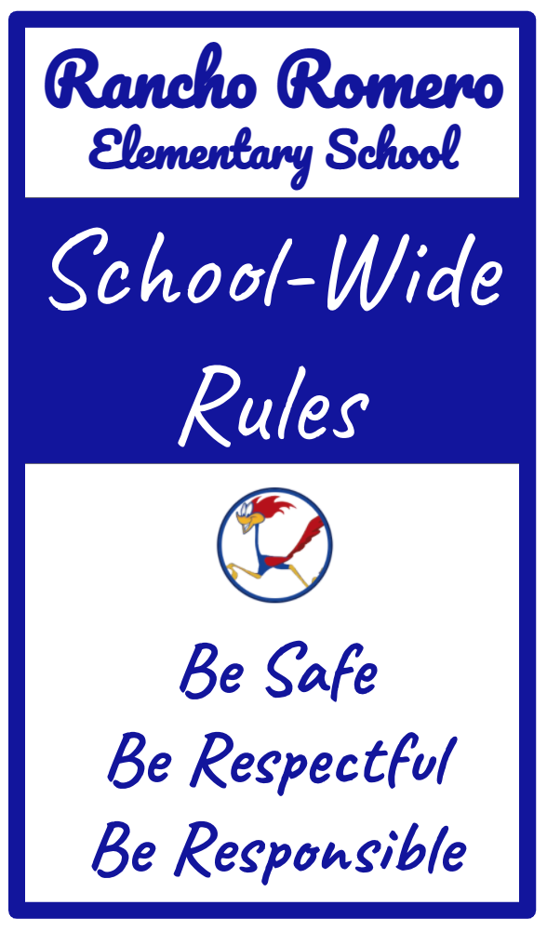

General Rules

- Students are to act in a respectful manner to other students and adults. Students need to follow the school-wide rules of: Be Safe, Be Respectful, and Be Responsible
  - Students will not use inappropriate language or gestures.
  - Students are to refrain from activities that physically or verbally hurt others (chasing, pushing, name calling, spitting, threatening, etc.).
  - Students are to follow the directions of ALL adults in the school.
  - Defiance of authority and/or disruptive classroom behavior is not permitted, and are suspendable offenses.
- Rough play, play fighting, throwing rocks, and possession of dangerous or disruptive objects/weapons, and possession of alcohol/drugs are suspendable offenses and will not be tolerated.
- Students will respect all school property and the property of others. Graffiti may result in a financial obligation for parents.
- Students are to remain under the supervision of an adult at all times and may not leave designated play areas or remain in classrooms alone.
- Students are to walk quietly in all areas of the school.
- Students are not to bring or chew gum, candy, or sunflower seeds at school.
- Students are not allowed to climb or hang off any railings, balconies or stage, or climb trees.

THIS IS STRICTLY PROHIBITED.

Hallway Rules

- Students must walk in the halls at all times – running is never allowed.
- Students should always stay to the right in the hallway when passing.
- No eating of any kind in the hallways.
- Students should always use “inside” voices in the hallways.

Recess/Snack Rules

- Students are to walk quietly to the designated area in an orderly manner and sit in assigned areas.
- Students are responsible for cleaning their own area after eating.
- Students are expected to talk in quiet, respectful voices.
- Students are to walk in an orderly manner to the playground after being dismissed by a teacher/noon duty supervisor.
- Students are to bring food and/or appropriate drink items in plastic or metal containers only. Glass containers are not allowed as they pose a safety hazard.
- Food must stay in the designated area and may not be brought out on the playground.
- Students must throw their trash away.
*Students who need more time need to work with school staff to make special arrangements.

PLAYGROUND RULES, PLAY SKILLS, AND GAME RULES
- Students are to be respectful and kind to one another and to the adult supervisors. They need to take responsibility for the care of themselves, property and our campus, too.
- Students are to obey yard supervisors and others in authority.
- Students are to behave in such a manner that will prevent injury to others and to themselves. Inappropriate behavior can result in suspension.
- No fighting is allowed. Students are encouraged to utilize conflict resolution skills or words to solve problems.
- Students are to be in designated areas only; bathrooms and courtyards are not considered play areas.
- Students are to stay on the playground unless a school staff member gives them permission to leave.
- Students are to use all equipment safely and appropriately.
- Inappropriate language is not permitted.
- Tackle football or rough play that endangers others is not allowed.

Upper and Lower Yards

- No hitting or kicking of other students. Keep your hands and feet to yourself.
- No playing in the ditch, behind the baseball backstops or in any area that is hidden from the vision of the playground area.
- No ball kicking on the blacktop area. Ball kicking is permitted on the grass area in an organized game that is designated for kickball, three flies up, soccer, two-hand touch football, etc.
- No hanging on tree branches and basketball hoops.
- No students should be excluded from a game for the entire recess. Some games have a maximum number of players such as GaGa and basketball. However, there should be a rotation in place for everyone to have a chance to play.
- No balls/equipment should be brought from home to school.
- No running in walkways/hallways.
- No loitering in hallways or courtyards during recess time.
- No balls are to be hit against CLASSROOM/BUILDING WALLS.
- No entering the parking lot without permission from a teacher, staff member or yard duty personnel.
- At the sound of the bell/whistle, students freeze and take a knee. When signaled by a yard supervisor students with equipment will be prompted to put their items away first then walk to their line up areas. At the second signal, the yard supervisor will dismiss the remaining students to walk to their line up areas.

Play Structure Rules

- Slides: Only one student on a slide and ladder at a time. Students may only sit on their bottoms when using the slide in a downward direction. No climbing UP the slide!
- Monkey bars, rings and pull-up bars: You may hang by your hands only! No hanging/flipping upside down, spinning around the bars, jumping from one bar to another or sitting on top of bars.
- Play Structure Area: No running, playing tag or pretend fighting/shooting. No climbing on the outside of the rails. No balls allowed in the area. No jumping on the bridge (upper yard).

Swing Set Rules (Upper Yard)

- One person on a swing at a time. You must hold onto chains with BOTH hands!
- The person waiting next in line sits on the cement border and counts slowly to 120 before having a turn on the swing.
- No standing or walking through the tanbark area while others are swinging.
- No climbing on the poles.
- No standing on the swings, laying on your stomach (Superman) or back and swinging.
- No jumping or flipping off of the swings.
- No pushing other students on the swings.
- No running under the swings.
- No throwing balls at students on the swings.
- No kicking balls while on the swings.
- No holding hands on the swings.
- No twisting the chains on the swings.
- No swinging sideways or bumping into others who are swinging.
- No saving swings for other students.

Rainy Days

- All students will remain in their classroom during rainy day recess.

Play Skills

These suggestions will help students learn the rules to common games played at recess during school. They will also help students understand the social skills of being a good sport. Knowing the rules and being a good sport are equally important for students during play. When students know the rules and play cooperatively, friendships can develop. Play skills improve with motivation and repeated practice (e.g. weekly play dates with classmates, friends or relatives; practicing these skills at home, in the park or community).

Sometimes students have trouble agreeing who should start the game first. This can be easily and fairly decided by chance. Some examples of chance are:
- Rock-paper-scissors or any game like it.
- Flipping a coin and guessing heads or tails.
- Writing a number from 1-10 on a piece of paper and having the students guess the number; the closest guessed number goes first.

The Social Skills of Sportsmanship
How to be a good sport:
- Smile
- Be positive
- Be honest
- Play fair
- Play by the agreed upon rules
- Cooperate with others
- Try your best
- Use problem-solvings skills to resolve issues
- Be a humble winner
- Learn from your losses
- Remember, it’s only a game. The most important thing is that everyone has fun!

Game Rules

Four Square

- Four/three/two people play with a ball in the four square area.
- The player in the service square always serves.
- The ball is served by dropping and hitting it underhand after the bounce to another square.
- There are second serves when the server serves the ball not hit the ball out of bounds.
- The player receiving the serve hits the ball after the bounce to another square.
- Play continues until someone hits the ball out of bounds.
- No overhand hits.
- No slam, smash or spin serves.
- No catching, carrying, holding or throwing the ball. The ball must be struck.
- The ball may only bounce once and players may only hit the ball one time (no double hits).
- All lines are “inbounds”.
- Players may hit the ball one-handed
- The object of the game is to not hit the ball out of the court or make any fouls. The most skillful or lucky player wins each round and remains in square D for as long as possible.
- Creative variations of the rules are encouraged as long as a majority is in agreement; it is safe and fair, does not intentionally exclude any one for any reason and does not give an unfair advantage to a particular person or persons.

GaGa

- GaGa is played with 2-20 students in the GaGa Court.
- The game starts with all players having their heels and hands against the wall.
- The ball is served by tossing it in the air and saying, “Ga Ga Ga” as the ball bounces 3 times.
- A player gets another person out when she/he hits their body with the ball BELOW the knees.
- The first two people in line or first two people out become the judges and the GATE.
- Once you are out of the game, you must exit the court and line-up again.
- If a disagreement occurs, the judges have the final say.
- No playing until the end. When there are 3 players left, a count down from 20 ranchos occurs. After which a new game is started
- No lifties. Hitting the ball on the third board or over the wall is not allowed.
- No double touches. The ball must hit a player before hitting the ball again.
- No tea parties. Players may hit the ball two times consecutively against the wall and then must try to hit a player.
- No fists. The game is played by striking the ball with one or two open hands.
- No touching the ground with any part of your body other than your hands or feet.
- No using the wall to jump.
- No jumping over the wall to enter or exit the GaGa Court.
- No chanting or name-calling.
- No teams or ganging up on players.
- No kicking the ball.
- No touching other players or throwing the ball at a player.
- No squatting or “mini-me’s” next to the wall. You must be in the middle to squat down.
- No “Ghost’ players. When you are out, you must exit the court immediately.
- NO SITTING ON THE WALL!
- Creative variations of the rules are encouraged as long as a majority is in agreement; it is safe and fair, does not intentionally exclude any one for any reason and does not give an unfair advantage to a particular person or persons.

Handball

- The object of the game is to hit the ball more skillfully than the other player, so that the other player cannot get the ball or hits it out of bounds.
- The ball is good only if it bounces inside the court. Lines are OUT!
- If there is a disagreement about whether the ball bounced in or out of the court, the majority of the students waiting in line will decide the call.
- Double or single fist hits are ok.
- Oreo’s, Waterfalls & Crackies are allowed.
- Players in line may not enter the court at any time.
- Player One (winner) serves the ball to start the game. You must stand behind the white line on the court.
- Player Two (new player) may choose UP TO two special rules from the list below:
- Backcourts – the ball can bounce outside the end line. Only allowed on the court facing the basketball courts.
- Cherry Bombs – players may catch the ball and throw it with a bounce at the wall.
- Rainbows – run under the ball instead of hitting it. Counts as your hit.
- Birdies – dribble the ball before hitting it. 10 second maximum.
- Bubbles/Dots – hitting the ball in the air, letting it bounce once and then hitting it against the wall.
These ARE NOT ALLOWED:
- No Pink/Blue Elephants – walking along the wall and trying not to get hit by the ball.
- No Black/White Elephants – running to the wall with the ball.
- No Dragons – double hits.
- No standing or entering the court.
- No interfering with the ball at any time!
- No king of the court. When a player wins three games in a row they are retired to the end of the line. Two new players enter the game.
- Creative variations of the rules are encouraged as long as a majority is in agreement; it is safe and fair, does not intentionally exclude any one for any reason and does not give an unfair advantage to a particular person or persons.

Kickball

- Two teams play with the designated ball on the blacktop court closest to the swings and basketball courts.
- There are 4 bases (e.g., 1st, 2nd, 3rd, and home base).
- There is one pitcher for each team. The pitcher stands in the middle of the square and rolls the ball toward home base so that the player can kick the ball.
- After the player kicks the ball, she/he runs to first base as fast as she/he can run.
- The kicker must kick the ball at home plate – not past it or they are out.
- If the 1st base person can catch the ball and tag the runner before she/he touches the base, then the runner is out. If the base person cannot tag the runner with the ball, then the kicker is safe. The player runs to the next base, when her/his teammate kicks the ball. If the ball is caught, the runner must go back to the base she/he came from.
- The object of the game is to get as many runs as possible. The winner of the game is the team that has the most runs.
- Play continues until there are 3 outs, and then it is the next team’s turn to kick.
- If the other team catches the ball after a ball is kicked, the player is out. More than 1 out can occur at a time (e.g., two people could be tagged running to two different bases). NO PEGS!
- If a ball is kicked outside of the kickball square, the kick is considered a foul and the ball is pitched again.
- The teams determine how long the game will last (e.g., until the recess bell rings, number of innings, runs scored or amount of time).

Tetherball

- Player One (winner) is the server.
- Player Two (new player) chooses side and direction.
- As the ball is hit back and forth with open hands or fists, each player tries to hit it so the rope winds completely around the pole in the direction in which she/he is hitting the ball.
- Players may do two bubbles (hitting the ball to themselves) before hitting the ball.
- No hitting the ball with any part of the body other than the hands or forearms.
- No catching or holding the ball during play.
- No touching or using the pole to jump.
- No hitting the rope with the forearms or hands.
- No grabbing the rope and throwing the ball even on the serve.
- No hanging on the rope or ball.
- No KICKING the ball.
- No king of the court. After 3 wins the player is retired to the end of the line and two new players enter the court.

Spider Rules

- The object of the game is for the “Corners” to switch places five times before the “Spider” gets to one of their spots.
- There are FOUR students standing on the “Corners” of a four square playing area and the “Spider” stands in the middle.
- If 5 switches happen, then the Spider goes to the end of the line and the next person in line becomes the new Spider.
- If the Spider gets to a corner spot first while a switch is occurring, then the Corner goes to the end of the line and the next person in line becomes the new Spider.
- If a Corner and a Spider go for the same spot and there is a tie, the tie goes to the Spider.
- If two Corners go for the same spot and there is a tie, then the two players do Rock, Paper, Scissors ONE time to decide who stays.
- Switches must occur every 30 seconds, otherwise all corners are OUT.
- Cross Country switches are when two Corners diagonally switch places. This counts for 2 of the 5 switches because it is much harder to do.
- The Spider may call ONE Scramble per game maximum – all corners must change places.
- No switching corners when disagreements are happening. All players must be ready before switching!
- No calling “NEW” Court or making up rules.
- No Cow Shoves – the Spider or Corner try to shove someone off their spot.
- No Bear Hugs – hugging a Corner and moving them off their space.

Basketball Rules

- No one court can be taken over by a single grade level. For example, if the 3rd graders decide they want to play a full court game on the tall hoops but the 4th graders want to shoot around or play Knockout on the tall hoop half court then the 3rd graders must play a half court game. Each half court can be used by different grade levels playing different games or shoot arounds.
- Grade levels can play together but if making teams the grade levels must be mixed. No all-5th grader teams playing all 3rd-grader teams unless there is a mutual agreement to play against each other.
- No pushing, physical or aggressive play.
- No showing off/show boating allowed.
- No ball hogging. All players must have a chance to touch the ball.
- No kicking or throwing the ball in anger or a disagreement.
- No hanging or grabbing onto net or rim.
- No wrestling over the ball. As soon as two players have their hands on the ball at the same time it’s an instant jump ball. No exceptions.
- In a full court game, no more than 7 on 7. In a half court game, no more than 5 on 5. All others will be subs. Subs count 50 ranchos then substitute for anyone they want on either team during a break in play, e.g. ball goes out of bounds, made shot or jump ball. No one can say no or pretend they didn’t hear them or delay the substitution in any way.
- Everyone that wants to play gets to play whether it is a basketball game, knockout game or a shoot around game.

Black Top Free Play

- Any other games or activities played on the black top must be played in the open middle area that is bounded by the ball walls, tetherball poles and GaGa pit.
- Any catching or tossing games must be played away from the parking lot fencing.
- Be aware of your surroundings. Do not throw a ball or engage in any other play without checking your surroundings.

CODE OF CONDUCT

Nondiscrimination/Harassment/Anti-Bullying (BP 5145.3. Click here for the policies.)

District programs and activities shall be free from discrimination, including harassment, intimidation or bullying with respect to sex, gender, gender identity or gender expression, ethnic group identification, race, ancestry, national origin, religion, color, physical or mental disability, marital or parental status, age or sexual orientation.

Acceptable Use of Electronic Communication

As the use of digital technology becomes more prevalent throughout our schools, the San Ramon Valley Unified School District is committed to helping students learn the responsible use of such technology in a safe and appropriate manner. This document serves as a reminder to parents and students that cell phones, cameras, video cameras, websites and other means of transmitting electronic data can be disruptive and/or harmful, with respect to themselves, other students and staff, as well as the overall school environment. The following information has been developed with the safety of all students and staff in mind.

Cyber Bullying

Cyber Bullying is the use of electronic information and communication devices to willfully and repeatedly harm either a person or persons through the medium of electronic text, photos, or videos. Examples of this behavior include but are not limited to:
- Sending/posting false, cruel, hurtful or vicious messages/comments.
- Creating websites that have stories, cartoons, pictures, and jokes ridiculing others.
- Breaking into an email account and sending vicious or embarrassing materials to others.
- Engaging someone in electronic communication, tricking that person into revealing sensitive personal information and forwarding that information to others.
- Posting of a student picture without their permission.
Bullying of this nature creates a hostile, disruptive environment on the school campus and is a violation of the students and staff member’s right to be safe and secure. Actions deliberately threatening, harassing, intimidating an individual or group of individuals, placing an individual in reasonable fear of harm or damaging the individual’s property; or disrupting the orderly operation of the school, will not
be tolerated and may lead to consequences.

Inappropriate Use of Technology

The fundamental principles behind these policies are that students should never do anything that harms another student or prevents them from learning. Any use of technological media that interrupts a student’s right to learn will not be tolerated. Electronic media includes, but is not limited to: social networking sites, chat rooms and discussion groups, instant messaging, text messaging, computers, cell phones and personal digital devices, digital cameras, cell phone cameras, and webcams. As new technologies emerge, they too may be included with the above forms of electronic communication. Examples of this behavior include but are not limited to:
- Sending, sharing, viewing, or possessing pictures, text messages, emails, or other material of sexually explicit, graphic, or disruptive nature on any device is prohibited on a school campus.
- If the conduct occurs off school grounds and causes or threatens to cause a substantial disruption at school or interferes with the rights of students or school staff to be secure, school administration may impose consequences. The Administration may also report Cyber Bullying or Harassment to the police.

Consequences – Inappropriate Use of Technology

Education Codes 48900.4 and 48900 (r), strictly prohibit harassment or bullying of any kind and such behavior is subject to consequences, including possible expulsion.
- Sexually explicit material that is transmitted electronically may result in parents or police being notified, and that material may be reported as suspected child abuse or neglect.
- All students involved in the transmission and/or possession of such images or text may be disciplined under California Education Code 48900 (i): Committed an obscene act or engaged in habitual profanity or vulgarity.
- If reasonable suspicion exists that a student has been involved in possessing or transmitting such material, the electronic device involved may be confiscated and searched by school officials.
- The transmission of such material involving another student may be punished under California Education Code 48900 (r): Engaged in an act of bullying, including, but not limited to, bullying committed by means of an electronic act, as defined in subdivisions (f) and (g) of Section 32261, directed specifically toward a pupil or school personnel.
- Additionally, Education Code 48900 (k) states that any disruption of school activities or otherwise willful defiance of the valid authority of supervisors, teachers, administrators, school officials, or other school personnel engaged in the performance of their duties can also lead to suspension.
*** Education Codes 48900.4 “Harassment, threats, or intimidation creating an intimidating or hostile educational environment” Education Code 48900 (k) “Disrupted school activities or otherwise willfully defied the valid authority of supervisors, teachers, administrators, school officials, or other school personnel engaged in the performance of their duties” Education Code 48900 (i) “Committed an obscene act or engaged in habitual profanity or vulgarity 73 Education Code 48900 (r) “Engaged in an act of bullying, including, but not limited to bullying committed by means of an electronic act, as defined in subdivisions (f) and (k) of Section 32261, directed specifically toward a pupil or school personnel”

Action Steps to Respond to Bullying or Harassment

Any student who receives such an image or message against their will should:
- Inform a school official immediately.
- Save the evidence. Print the online harassing text if possible.
- Identify the bully.
- Clearly tell the bully to stop.
- Ignore the bully by leaving the online environment and/or blocking communications.
- File a complaint with the Internet or Cell Phone Company.
- Contact the bully’s parents.
- Contact the police.

Suspected Bullying

All students, employees, parents and community members should report incidents of suspected bullying/harassment/discrimination immediately to the teacher and principal. An investigation will be conducted to determine if bullying occurred and corrective action needed.

Discipline Steps for Most Cases
Level 1 - A warning, restatement of school rules, or a work detail is assigned at this level. Parents are not notified at this level.
Level 2 - Notification of parents; possible parent conference, loss of privilege.
Level 3 - Notification of parents, increase in loss of privilege or partial loss of recess, possible referral to Student Study Team, SCIP counselor or School Psychologist.
Level 4 - Parent conference, possible behavior contract, and increase in Level 3 loss of privilege, referral to principal.

Consequences

Students are expected to follow all school rules to ensure a safe, respectful, and responsible environment
in which to learn. Various strategies will be utilized by teachers, supervisors, and administrators to
remediate inappropriate behavior. Example consequences that may be used when school rules have been violated include:
  - Denial of a Privilege: Lost privileges may include loss of playtime during recess, time out, exclusion from classroom activities, assemblies, or field trips, etc.
  - Individual Assignment: Students can be asked to complete a written assignment related to the infraction.
  - Community Service: Students may be asked to pick up trash around the school (gloves are provided) and/or any other community service assigned by an administrator.
  - Parent Contact: Phone calls, letters and/or conferences will be utilized to inform parents of concerns and possible solutions. It is expected that parents will discuss the problem with his/her child and institute a consequence at home when appropriate. WRITTEN NOTICES ARE TO BE SIGNED BY THE PARENT AND RETURNED THE FOLLOWING DAY IN ORDER TO AVOID AN ADDITIONAL CONSEQUENCE.
  - Suspension: Please see the Comprehensive Safe School Plan for suspension information.
  - Restitution: Students who lose or willfully deface, destroy, or steal school property (texts, library books, etc.) or property of others, may be expected to clean up, repair, replace, and/or pay for the item(s) involved.

Grounds for Suspension and Expulsion (BP 5144.1 click here)

In addition, please see the Comprehensive Safe School Plan GROUNDS FOR SUSPENSION AND EXPULSION.

PROGRAMS AND ORGANIZATIONS

Gifted and Talented Education (GATE)
The CogAT is used to initially identify grade 2 students who are eligible for the Gifted and Talented Education (GATE) Program. This test consists of three batteries, which measure verbal, quantitative and nonverbal abilities. Students in grade 2 take the CogAT in their classrooms. Students in grades 3-4 may take the CogAT in the fall of each year. In addition, students in grades 5-7 who have not previously taken the CogAT may take it in the fall. Students must be registered in order to take the CogAT in the fall.

Student Council

Rancho Romero has an active Student Council that meets bi-monthly. The Student Council functions as an association with a set of bylaws written by the students. Officers are elected from grade 4 and 5 students. Each grade 4 and 5 class elects representatives. Students participate in various service activities and sponsor events that promote school spirit.

Library

A part-time library media coordinator staffs the library. Students visit the library once a week as per the library schedule. Library is also open for students twice a week during lunch time. Students are encouraged to bring home their selections to share with parents. Students are responsible for the proper care and return of materials. Lost or damaged books need to be paid for. Students can also visit the library during recess/lunch when open. For more information click here.

Science Lab
The science specialists meet with Grades 1-5 classes once per week. During these 50-minute periods, students participate in hands-on enrichment activities that support and enhance their regular classroom science instruction, as well as encourage the development of analytical and problem-solving skills. Kindergarten students participate in science instruction in their classrooms.

Rainbow Program
The Rainbow Program is designed to help students get a good start in school, develop and enhance social skills, foster a healthy self-concept, and improve school adjustment. The program teaches empathy, social problem solving, and emotion management. Students may benefit from the Rainbow Room for many different reasons, such as new school adjustment, academic and/or peer pressures, excessive shyness, divorce, or making friends. This is accomplished by providing weekly one-to-one or small group sessions between a student(s) and a Rainbow Paraprofessional. This is not a counseling program and is not designed for students who require therapy. Referrals to the Rainbow Room come from teacher and/or parent requests.

Physical Education

The aim of Rancho’s PE program is to provide students with the knowledge and skills necessary to maintain an active, healthy lifestyle. PE instruction is provided to Grades 1-5 students twice a week for 50 minutes. PE grades are based on participation and cooperation. In order for your child to fully benefit from the PE class, we ask that your child dress properly for PE on their scheduled days:

- Athletic shoes with laces tied and socks – No skateboarder shoes with loose laces allowed, no Crocs, Keens, UGGs, sandals, etc.
- Comfortable clothes – If dresses are worn, please be sure shorts are worn underneath.

Injury or Illness on PE Days

PE is a mandated course. Students need to bring a note from a parent/guardian if they are unable to participate. This note is only valid for two PE classes. If more time is needed to heal, a note from a doctor is required. It is our belief that while an injury/illness may prevent a child from doing ALL activities during PE class, there are many activities in which they can still participate. Thus, all notes to the PE teacher should include:
- Specific injury or illness
- Specific activities child is not allowed to participate in
- Parent signature and phone number

Parent Teacher Association (PTA)
PTA membership is open to all parents, guardians, relatives, teachers, and friends of Rancho Romero students. A membership drive will be conducted during online registration; however, parents may join at any time and are encouraged to take an active role in this supportive organization.Click here for detailed information about the Rancho PTA.

Rancho Romero Education Fund (RREF)
The RREF is a registered not-for-profit organization made up of dedicated parents whose goal is to maintain and enhance the quality of education at Rancho Romero for all students. It raises money through optional donations, an auction, corporate matching gifts and other fundraising efforts in support of programs such as classroom paraeducators, art and music teachers, a library media coordinator, and math and reading specialists. Click here for detailed information about the RREF.

School Site Council
The School Site Council (SSC) is composed of an equal number of parents and staff members. Our Council is composed of six parents and six staff members. The SSC serves as the representative body for determining the focus of the school’s academic instructional program and all related categorical resources. Members are elected for two-year terms. Click here for more information about the SSC.

SUPPORT PERSONNEL

TSA Admin
A Teacher on Special Assignment (TSA) Admin will be available 2.5 days per week. The TSA Admin coordinates interventions, supports intervention staff, facilitates 504 Meetings, SST's and IEPs, supports teachers in the capacity of an instructional coach as well as provides Professional Development/trainings, and offers direct support to students for general wellness and safety of all students including supporting their SEL, behavioral, and academic needs.

Liaison
We have a liaison available on site 2.5 days per week to support the continuous cycles of improvement at each grade level/subject area. The liaison will work in coordination with the principal and staff to develop a road map to support students’ academic and SEL needs. They will be supporting teachers in successfully using student support/common learning time to meet students’ needs. In addition to supporting assessment and progress monitoring, the liaison will also be supporting teachers with Tier 1 instructional practices rooted in Deep Learning principles. Liaison will support the implementation of evidence-based strategies and best practices centered on equity that includes and affirms the diverse identities and experiences of our students and families.

Student Success Team (SST)
The Student Success Team consists of the teacher, parent, administrator/designee, liaison as well as additional school personnel as needed. The goal of the group is to understand the challenges and plan strategies to solve academic, behavior, social-emotional, or attendance concerns being experienced by a student. Parents are asked to consult with the referring classroom teacher in providing developmental history, health, and other pertinent information.

Resource Program and Specialist
The resource program is available to assist students with exceptional learning needs who qualify for special education under education code. The resource specialist coordinates meetings from parent referrals when final results from the SST recommend further investigation. In addition, the resource specialist works with teachers to accommodate curriculum to meet students' learning needs. The resource specialist works with students in the general education setting, as well as in small groups or on a one-on-one basis to address objectives/goals in each student’s Individual Education Plan.

School Counselor and School Counseling Intern Program (SCIP)
This year we have a school counselor available on site 2.5 days per week. In addition, SCIP, a counseling program sponsored by Discovery Counseling Center and SRVUSD, offers short-term individual and group counseling to students referred for counseling at Rancho Romero.

Sometimes students have personal or social issues that interfere with their ability to function their best at school. Counseling at school can offer students an opportunity to address these issues in their immediate environment. Referrals come from teachers, the principal, parents or students themselves. No student will be seen without written parental consent.

Speech and Language Therapist

Speech and language therapy is provided at Rancho Romero for students who have difficulty with verbal communication skills and language processing who qualify for special education services under education code. Students who meet criteria for speech and language services are enrolled in individual or small groups to work on specific goals listed in the student’s Individual Educational Plan.

Reading Specialists
The Reading Specialists and Instructional Assistant work with students in grades 1-5. Students are identified through a process based on data. Students receive 1:1 and/or small group support, which helps them to acquire the essential knowledge and skills necessary for their grade levels.

Math Specialists & Math Enrichment
The Math Specialists and Instructional Assistant work with students in grades 1-5. Students are identified through a process based on data. Students receive small group support which helps them to acquire the essential knowledge and skills necessary for their grade levels or for math enrichment purposes.

Psychologist
A school psychologist works at Rancho Romero 2 days per week, and may provide direct and/or indirect services to students. Direct services may include assessment (e.g. cognitive, processing, behavioral, social/emotional) to determine eligibility for special education services, and/or counseling (e.g. individual and/or small groups, as needed). Indirect services may include consultation with teachers and parents, and attending meetings to provide information to parents and/or staff.

Nurse & Licenced Vocational Nurse (LVN)
A nurse and/or LVN is available onsite. Services include first-aid, vision and hearing screening, consultations with students, teachers, and parents related to health issues and concerns, control of communicable diseases, and consultation with staff and students in areas of health education.

